**ANNOUNCING A BASKET CLASS AT BLUE KNOB GALLERY**

We are having a day where we will teach you how to make a basket with natural fibres such as NZ flax, red hot poker etc. All the fibre will be supplied.

**Where: Blue Knob Hall Gallery**

**Moore Workshop Space**

**When: Saturday 13th July 2024**

**Time: 9.30 to 3pm**

**Cost: $70 for the day**

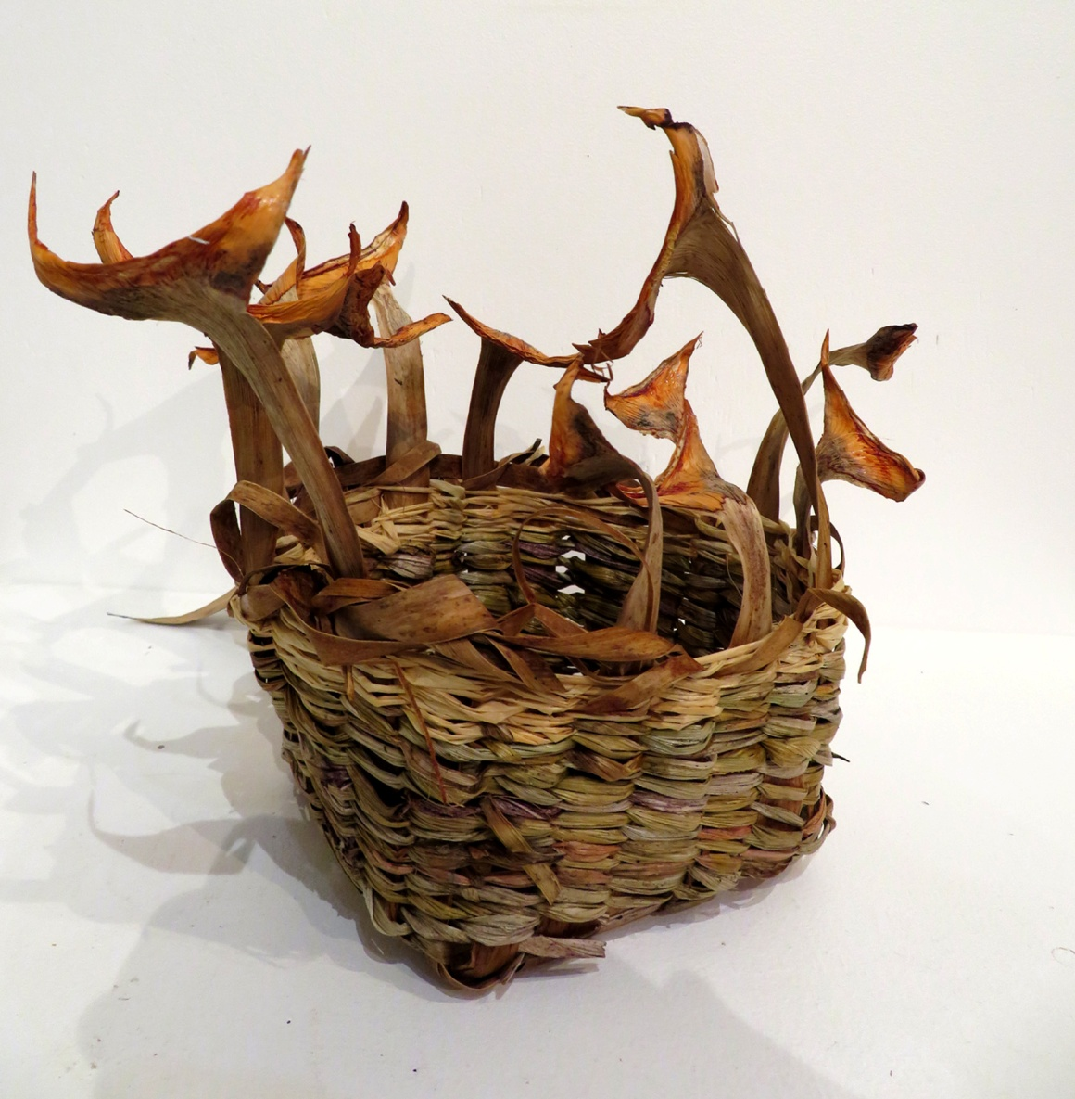

**‘Dragon Basket’**

The number of people is limited to eight so booking is essential.

If you would like to come along and end up with a basket made by your own hands give **Cherie or Fiona Shadwell a call on 663 22980 mob 0456081347**